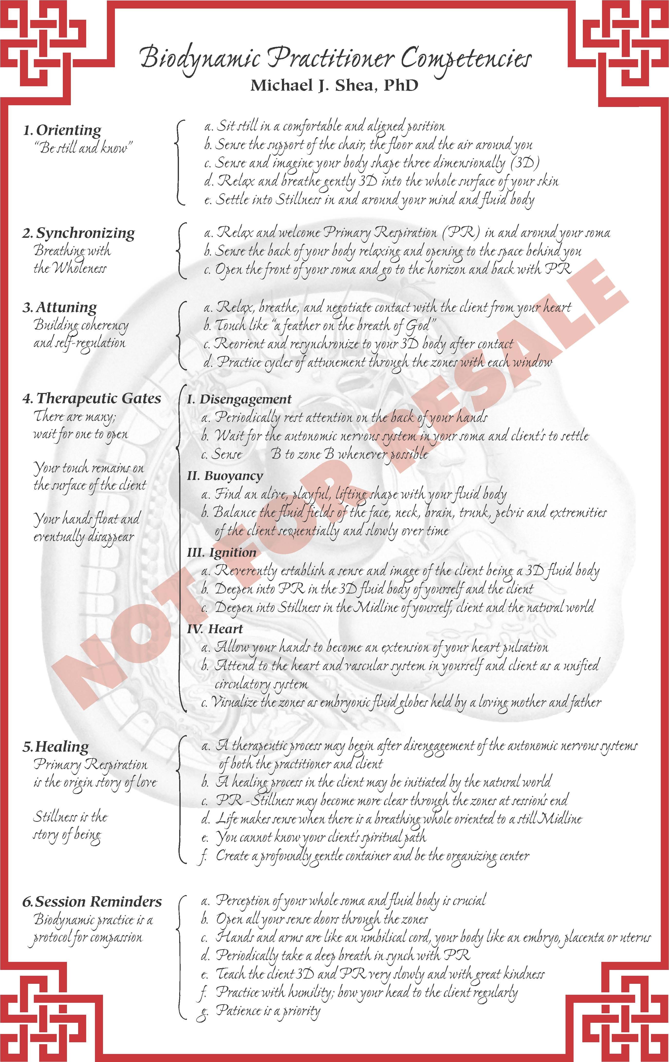
© 2010 Michael J. Shea edited by Carol Agneessens

